Lab 1 – Feasibility Model Phase 1

ECE 298 – S2021

|  |  |  |  |
| --- | --- | --- | --- |
| **Team Members** | Team Member 1 Barry Cimring  Team Member 2 Anweshi Avadya | **Team Number** | 90 |

# Part 1 – Project Design Requirements

1. **Functional Requirements**
   1. The motorized wheelchair must be able to rotate its wheel at a maximum speed of 1.67 m/s and minimum speed of -1.67 m/s when moving forward, which is approximately the speed of walking human adults.
   2. …
2. **Non-functional Requirements**
   1. The ramp-up of the motor controlling the speed of the wheelchair must be pleasing to the user of the wheelchair.
   2. …
3. **Constraint Requirements**
   1. The form factor of the PCB on which the hardware components for the design is built must be ___.
   2. …

# Part 2 – Project Considerations for I/O

## **Project Sensors and User Inputs**

**Potentiometer**

**Potentiometer Connection**

**Battery-Level Sensor**

A circuit will be connected to the external battery to measure its voltage level over time. It is assumed that the maximum possible battery that this project requires is 20 V. The battery-level sensor range must be able to transform a 20 V input voltage into a voltage on the range of 0-3.3V as input to the MCU’s ADC.

**Batter-Level Sensor Connection**

The circuit that will sense the battery level, whose maximum possible value is assumed to be 20 V, will be connected to the ADC peripheral device of the MCU. The voltage of the battery will be sent through an op-amp buffer to isolate it from the ADC. The output of the voltage buffer will then be connected to a voltage divider whose output range (for an input range of 0-20 V) is 0-3.3 V, the maximum voltage of the ADC. This can be achieved with a R! and R@ ohm resistor.

## Project Actuators and User Outputs

**Motor**

An actuator required for the project is a DC motor that will control the speed of rotation of the wheelchair’s wheels. It is assumed that the number of revolutions of the motor to the number of revolutions of the wheelchair’s wheels is 6:1. Thus, as per the functional requirement, the maximum/minimum rotation speed of the motor must be (if we assume that the wheel is of 0.25 m radius): . Therefore, the max/min rpm of the wheel is .

**Motor Connection**

Because the DC motor requires a negative voltage to spin in reverse, the motor will be connected to an analog OUT pin of the MCU via a series of op-amps. The first op-amp will reverse the polarity and reduce the value by a factor of two of the 3.3 V signal from the MCU. The second op-amp will add the voltage from the previous op-amp to an analog output signal from the MCU from 0 to 3.3 V. This puts the voltage range of the input to the motor at -1.65 – 1.65 V. In Part 3, when testing the motor we see that this is enough range to achieve the maximum/minimum speeds desired.

**Multicoloured LEDs**

**Multicoloured LED Connection**

**LCD – Liquid Crystal Display**

**LCD – Liquid Crystal Display Connection**

## Project MCU Internal Resources

**ADC – Analog to Digital Converter**

**ADC – Analog to Digital Converter**

**Internal MCU timer**

**GPIO**

**Interrupts**

**Software Parameters**

# Part 3 – Device Testing Methodology

## Device 1 – ECE298-MOTOR-BLDCM

The ECE298-MOTO-BLDCM is the brushless DC motor that will be used to control the speed of revolution of the wheels on the wheelchair. This motor’s rotation speed is controlled by a DC voltage, and the voltage/current that the motor draws from a power source is proportional to the rotation speed of the motor.

To control the device, a voltage source will be connected to the P1A pin only (explained below). This voltage source will be an analogue output pin from the MCU (check if this is allowed!!).

The schematic used to test the DC brushless motor is below:

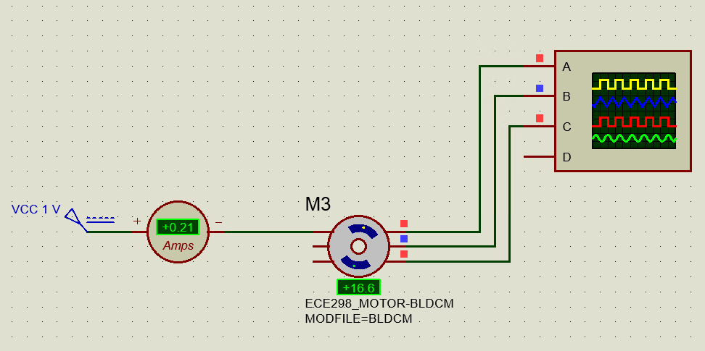

The DC motor’s P1A pin is connected to a voltage source of 1 V, drawing an average current of around 200 mA. The output B[1..3] pins are connected to an oscilloscope to monitor the output of the motor. It is seen that the rotation speed (in RPM) of the motor is directly proportional to the voltage supplied, where, at 1 V, the motor’s rotation speed is 16.66 RPM. The current drawn is similarly proportional to the rotation speed, drawing 200 mA/16.66 RPM = 12 mA/RPM. Below is an oscilloscope capture of the output of the B[1..3] pins for the same schematic:

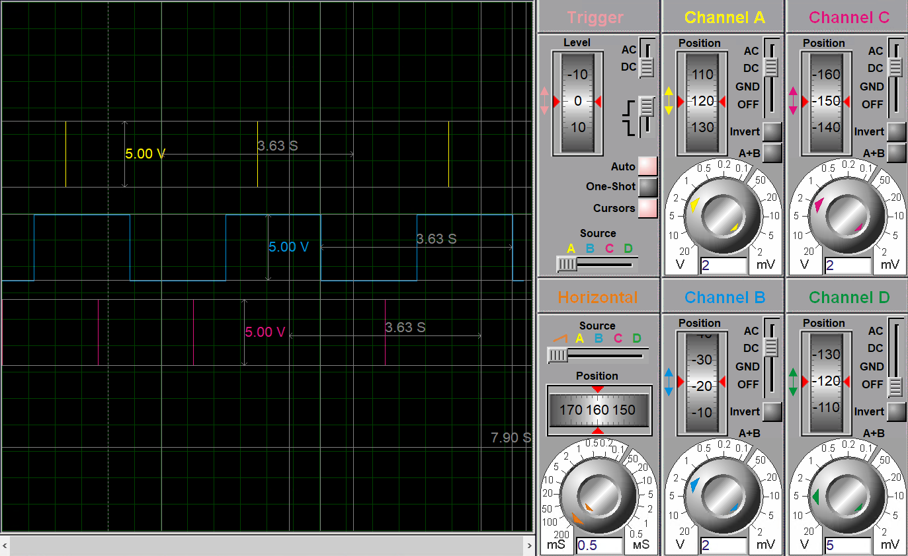

It is shown that to identify a forward rotation, the rising edge of B1 is when B2 is low. It is shown the output of the motor is a square wave from 0-5 V with a period of 3.63 s at 1 V input. This period is inversely proportional to the rotation speed. The duty cycle of the square wave is 50%.

We see that, in the same way, the motor will rotate in the opposite direction with the same magnitude of RPM if a negative voltage is applied:

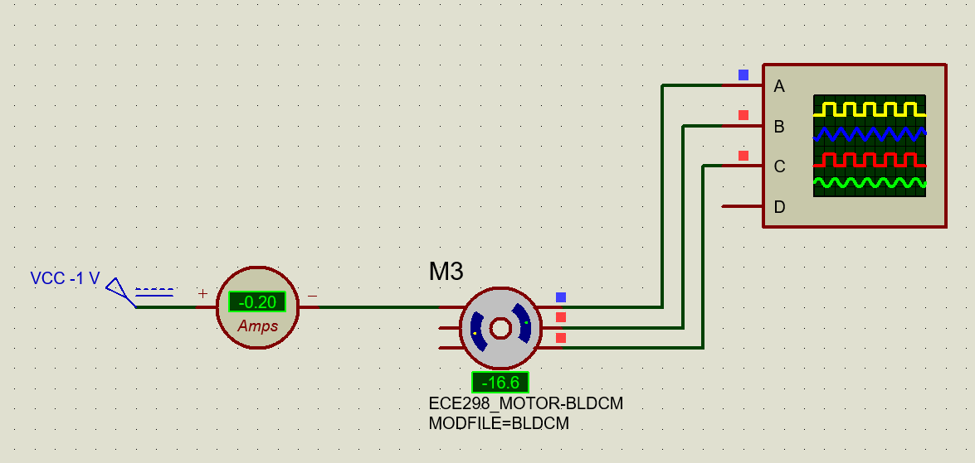

Likewise, the output corresponding to the speed of the motor looks like:

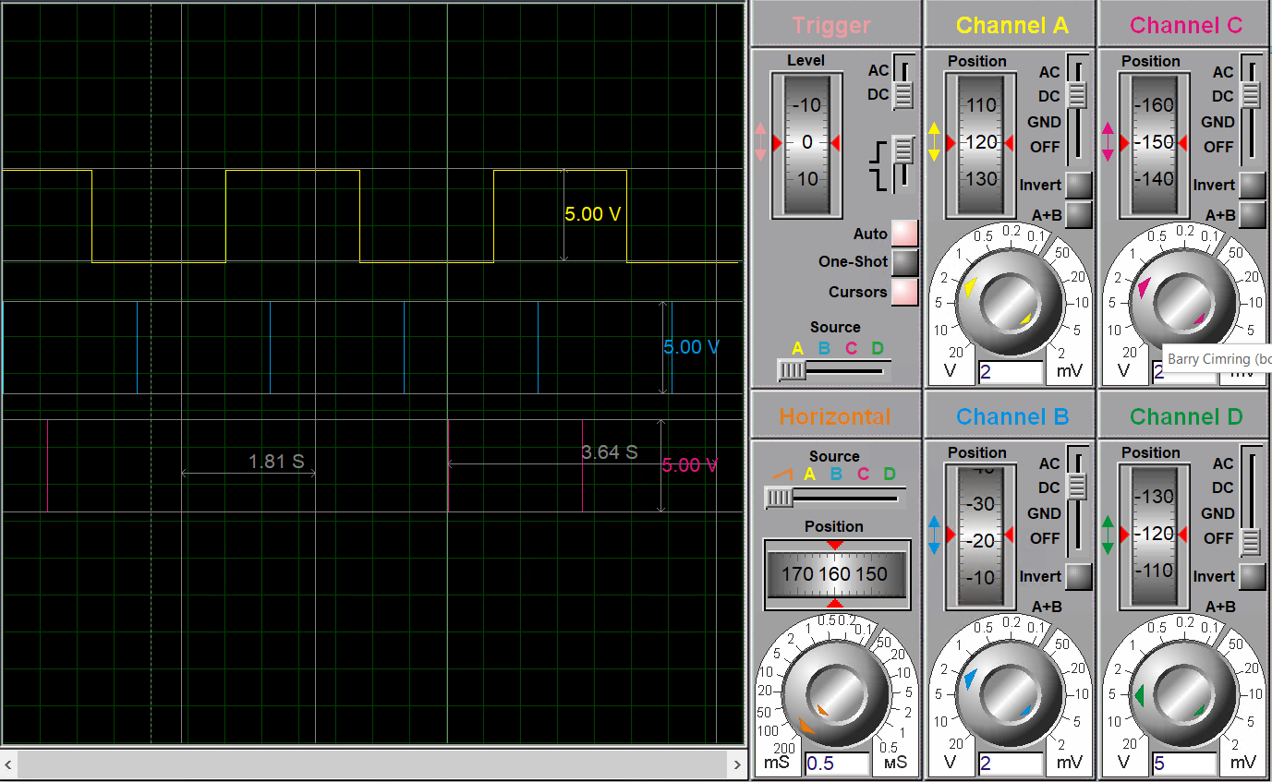

Where the rising edge of B1 occurs when B2 is high, and the rising edge of B2 occurs when B3 is also high – the opposite of a positive directed rotation.

When the same power supply is connected to P1 and P2, the rotation speed, and current drawn, doubles. Likewise, when all three pins are connected to power, the rotation speed, and current drawn triples:

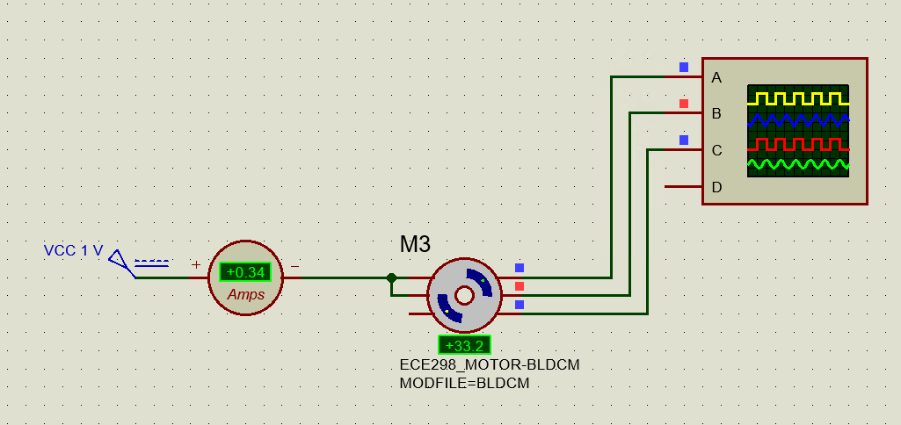 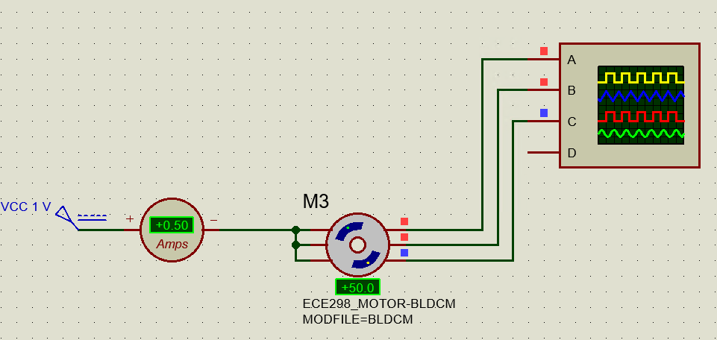

The same is true for negatively applied voltages.

## Device 2 – Battery-Level Sensor

The battery-level sensor circuit is designed to output a voltage between 0-3.3 V given an input range of 0-20 V, which is the assumed maximum voltage of an external battery for this application.

The output of this circuit will feed into the ADC peripheral of the STMicro…, which will be converted to a digital signal that the firmware of the MCU can read. Depending on the battery level, the MCU will determine which LEDs (indicating battery percentage) will be turned on.

A schematic for the battery-level sensor is shown below:

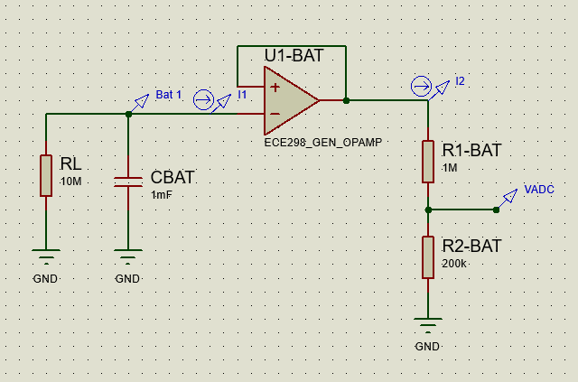

The battery is modelled by a large capacitor – CBAT – whose initial voltage is set to 15 V. The battery voltage is sent through a buffer to isolate the signal from the rest of the circuit (RL, representing the circuit load), which is the input of a voltage divider providing the correct maximum output rated for the MCU’s ADC. VADC will feed into the ADC of the MCU in the final implementation.

Due to the modelling of the external circuit as a large circuit, the battery’s voltage will drop exponentially over time (since the current drawn by the op-amp buffer is negligible). The lifetime of this battery is (rounded down). This is shown below in the time-domain voltage and current of VADC, Bat 1, I1, I2:

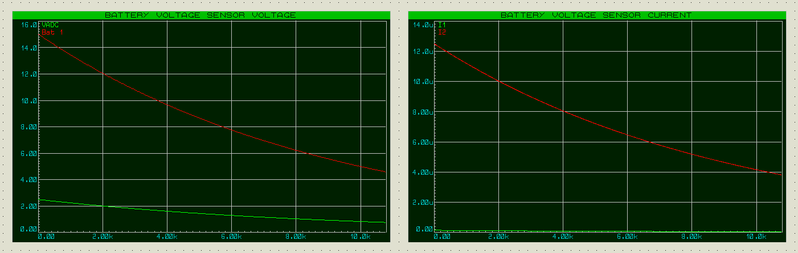

As shown the battery, in this configuration, retains at least 50% of its charge for 5.6k s = 1.5 h, which is exponentially decrease with the lifetime as stated above. The current drawn from the battery is negligible, and the current drawn in the voltage divider circuit is of the order of uA, which is also satisfactory. In this example the initial voltage read by the ADC would be 2.5 V – indicating to the MCU the battery is at 15 V charge.

## Device 3 – ECE298_DCMOTOR_ENCODER

The battery-level sensor circuit is designed to output a voltage between 0-3.3 V given an input range of 0-20 V, which is the assumed maximum voltage of

# Part 4 – System-Level Design

Insert block diagram and description